INDIA’S AGRICULTURAL PRODUCTION ANALYSIS

(1997-2021)

**INTRODUCTION**

**1.1 OVERVIEW**

India’s agricultural production analysis between 1997 and 2021 by tableau reveals significant growth and changes in the sector. During this period, India’s agriculture underwent various transformations, influenced by factors like technological advancements, Policy changes, climate variability, and market dynamics, etc.

* India’s agricultural landscape has diversified beyond staple crops like rice and wheat to include horticultural crops, oilseeds, and pulses. This diversification has been driven by changing consumer preferences and increased export opportunities this all we know by tableau.
* Government policies, such as Minimum Support Prices (MSP) and subsidies, continued to influence agricultural practices and income stability for farmers.
* The adoption of modern farming techniques, like precision agriculture and genetically modified crops, increased productivity. However, it also sparked debates on the sustainability and environmental impacts of such practices.
* India’s agricultural exports grew significantly during this period, with products like basmati rice, spices, and cotton gaining prominence in the global market we clearly visualize by tableau.
* As agriculture modernized, there was a shift in the rural population towards urban areas in search of alternative livelihoods, which impacted the demographic landscape.
* The COVID-19 pandemic posed new challenges to Indian agriculture, disrupting supply chains and affecting labor availability during critical planting and harvesting seasons this all we know by tableau.

In summary of our project in tableau we know India’s agricultural production between 1997 and 2021 demonstrated both growth and challenges. While technological advancements and policy reforms improved productivity and market access, sustainability, climate resilience.

**1.2 PURPOSE**

The analysis of India’s agricultural production between 1997 and 2021 in tableau serves several purposes:

* It helps evaluate the overall growth and trends in agricultural production over this period. This can be essential for understanding the trajectory of India’s agricultural sector.
* Analyzing production data helps ensure food security by identifying periods of surplus and scarcity. This information can guide food distribution and storage strategies.
* It allows for an examination of the environmental impact of agricultural practices, including issues related to soil health, water usage, and pesticide use.
* Tableau analysis can reveal shifts in crop choices and diversity, which is vital for sustainable agriculture.
* by tableau we understanding how climate change has affected crop yields and patterns is crucial for adaptation and mitigation strategies.
* Tableau analysis can shed light on the trade balance of agricultural products, including exports and imports, which is vital for India’s trade policies.
* in tableau analysis, It plays a role in assessing the development of rural areas, as agriculture is often the primary source of livelihood in these regions.
* The data aids in long-term planning for agriculture, guiding investments, infrastructure development, and research priorities.
* It assists policymakers in assessing the effectiveness of agricultural policies implemented during these years. This includes subsidies, support programs, and reforms aimed at boosting agricultural productivity.
* It provides insights into the income generated by farmers during this time frame. This is crucial for understanding the economic well-being of the rural population.

By tableau Analyzing this period can provide valuable insights into the challenges and opportunities faced by India’s agriculture sector, ultimately helping in the formulation of policies and strategies for sustainable growth.

**PROBLEM DEFINITION & DESIGN THINKING**

**2.1 EMPATHY MAP**

Empathy maps are a valuable tool used in design thinking and user-centered design processes to understand users better. It includes Says what the users says, Thinks it focuses on thoughts, Feels explores user's emotionals, and Does observes user's actions.

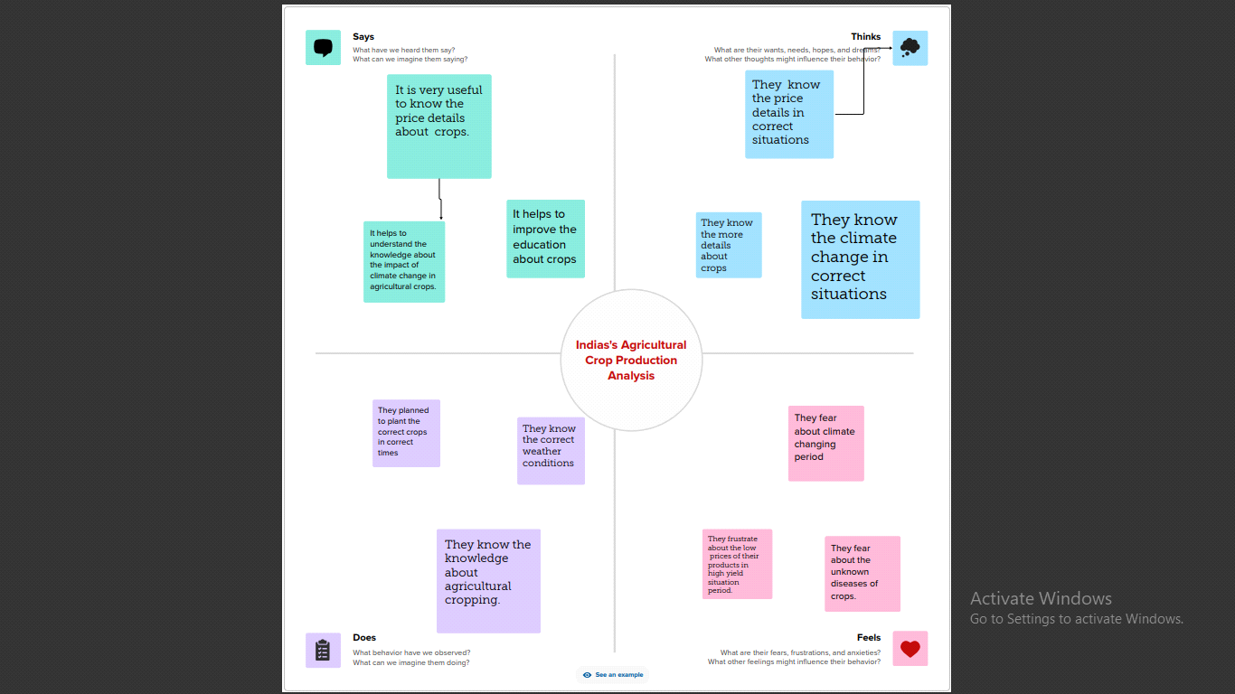

**2.2 IDEATION AND BRAINSTORMING MAP**

Ideation and brainstorming maps are visual tools used to generate and organize ideas. It can take various forms, but a common approach is to use a central concept or problem as the focal point and then branch out with associated ideas.

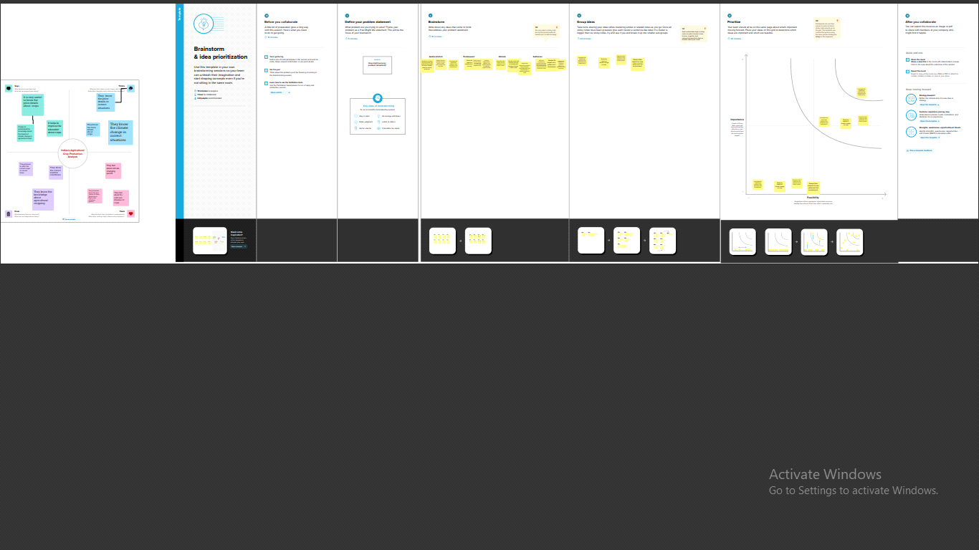

**Statewise agricultural land**

The below figure shows that statewise agricultural land and their yields. It provide valuable insights for various purposes, such as agricultural planning, resource allocation and development.

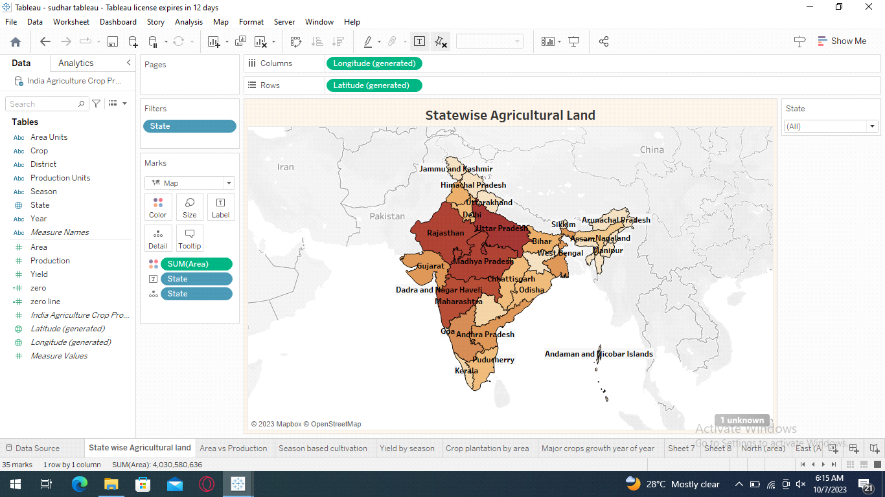

**Area vs Production**

The following figure shows that relationship between agricultural land area and production. It analyses India can yield important insights into the efficiency and productivity of the agriculture sector.

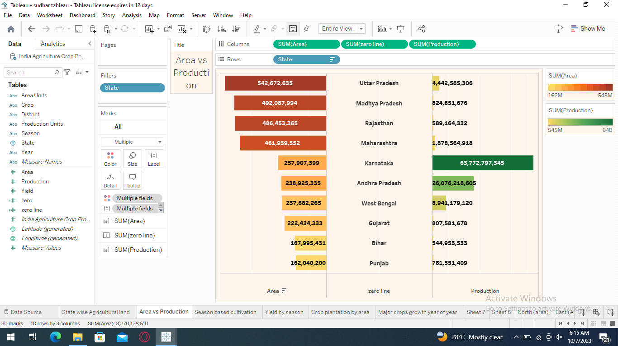

**SEASONED BASED CULTIVATION AREA**

The following figure shows that cultivation area based on season. It's important to note that the specific crop choices can vary within these regions, and climate conditions.

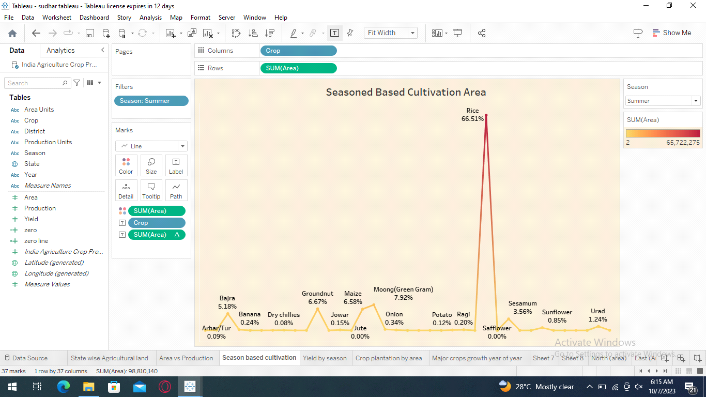

**YIELD BY SEASON**

The following figure shows that total yield by season. It's important to remember that crop yields can vary from year to year due to climate conditions and other factors.

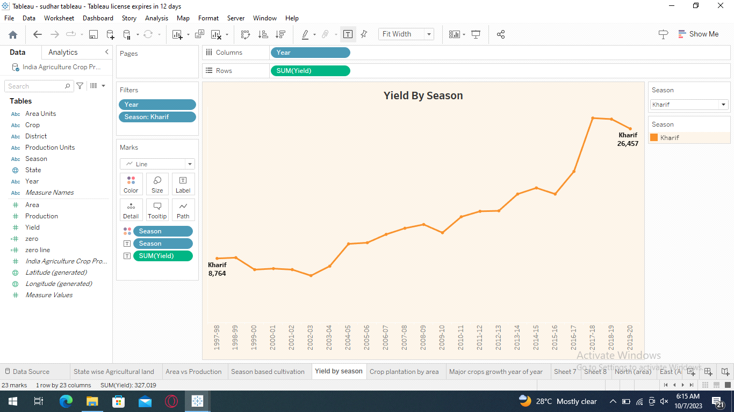

**CROP PLANTATION BY AREA**

The following figure shows that plantation of crops by area. It varies by region due to its diverse cllimate and geography. It helpful to know which plants are grow in a particular area.

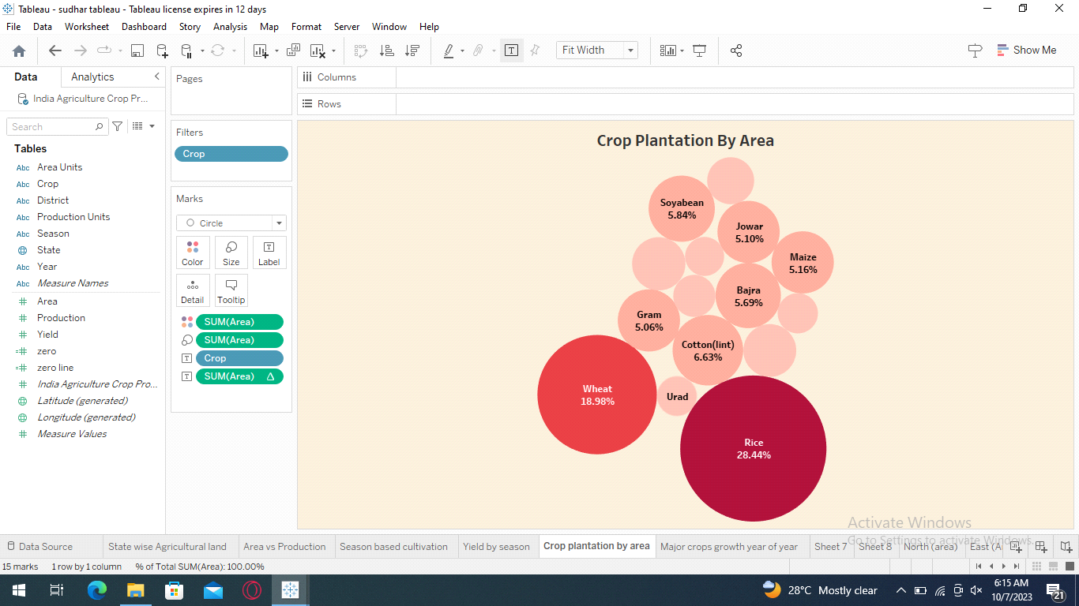

**MAJOR CROPS**

The following figure shows that major crops production in india. The specific crops grown in a region depend on factors such as climate, soil type and others.

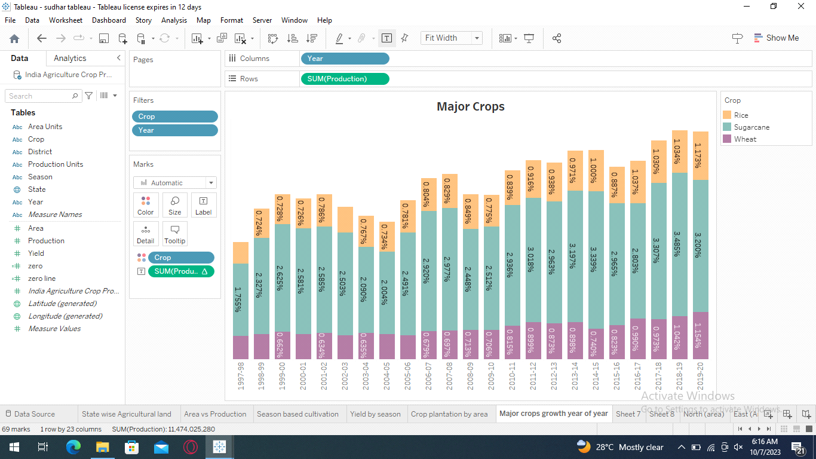

**CROP (Plantion by Count)**

The following figure shows that crop plantation by count. The count of crop plantation can very important to improve crop counting particular area and improve year to year.

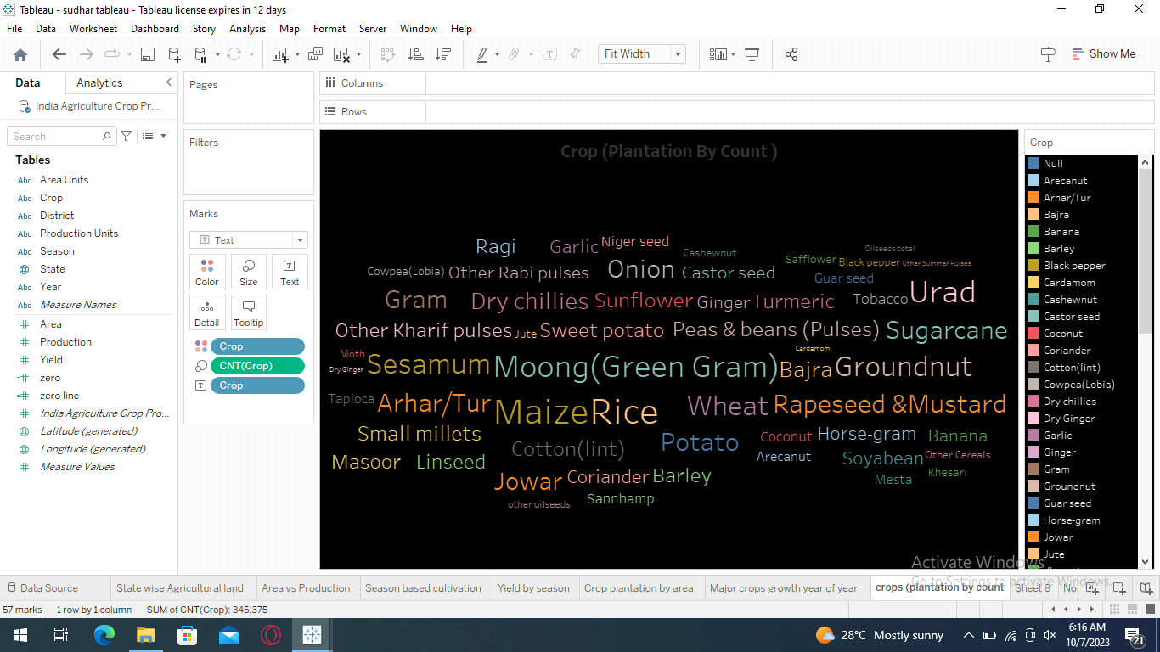

**SEASON WISE PRODUCTION**

The following figure shows that season wise production in India. Crop production in India is highly dependent on the season due to the country's diverse climate and agricultural practices.

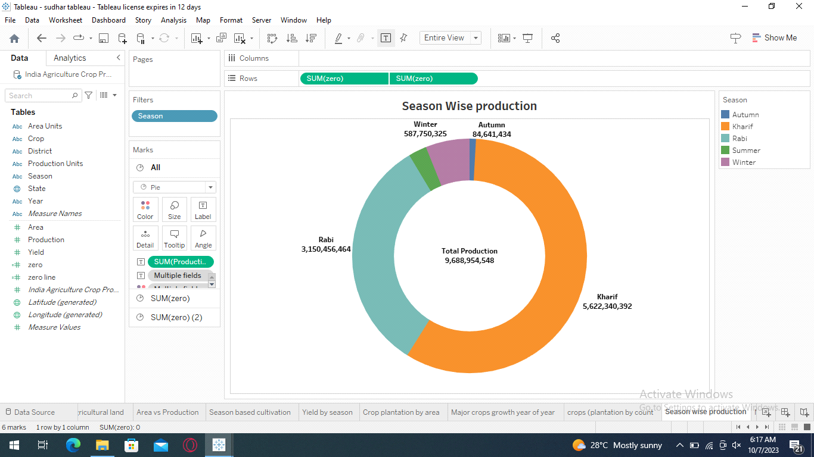

**NORTH (area)**

The following figure shows that northern area land of India. The northern region of India is quite vast and it consists of numerous states and union territories.

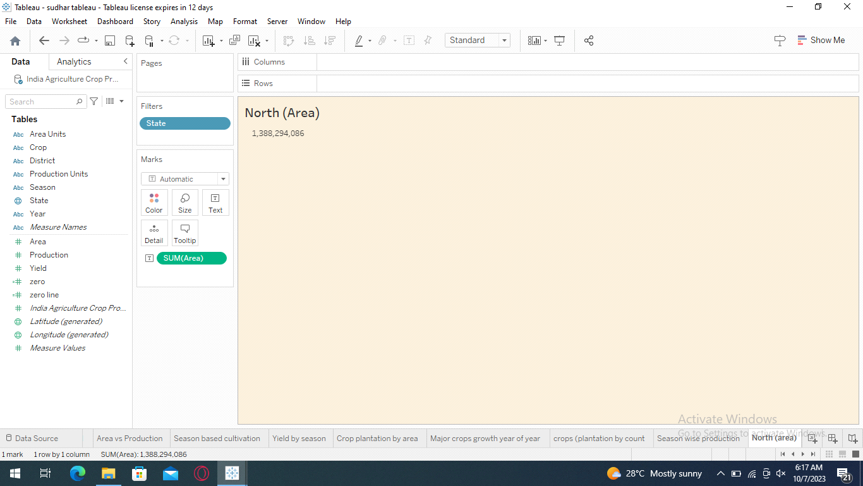

**EAST (area)**

The following figure shows that Eastern area land of India. It is also quite exxtensive and includes several states and union territories.

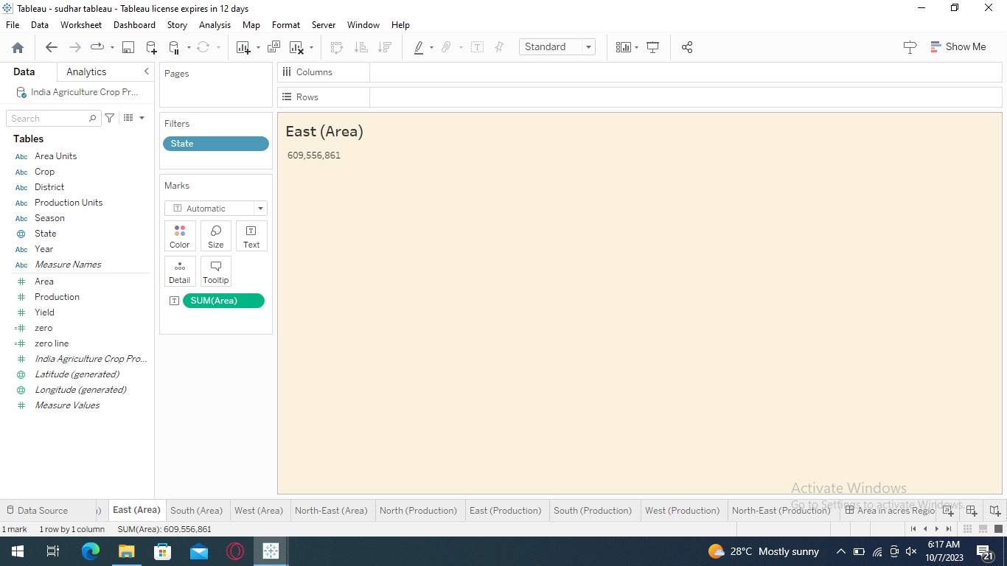

**SOUTH (area)**

The following figure shows that southern land area in India. This region comprises several states and union territories.

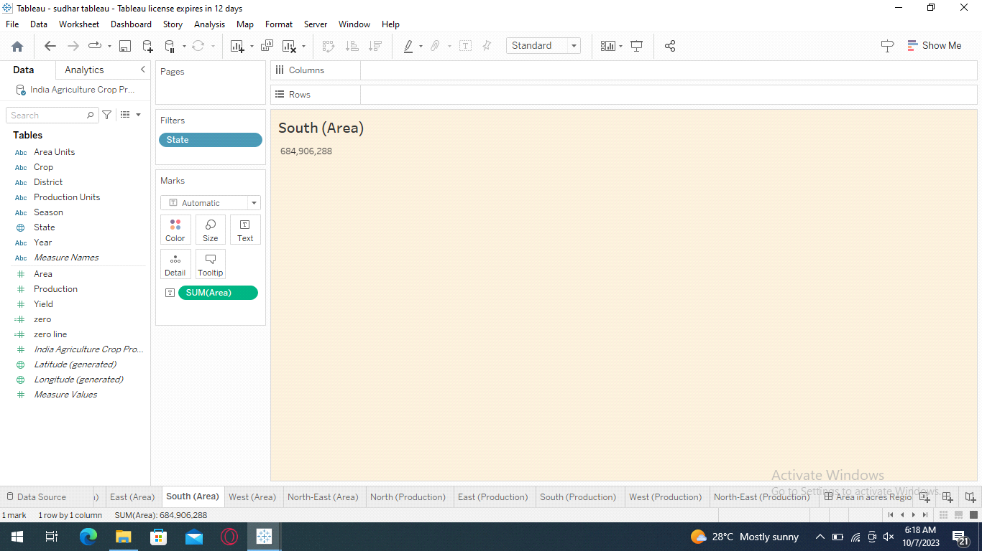

**WEST (area)**

The following figure shows that western land area in India. It is known for its diverse geography, icluding deserts, coastal areas and fertile plains.

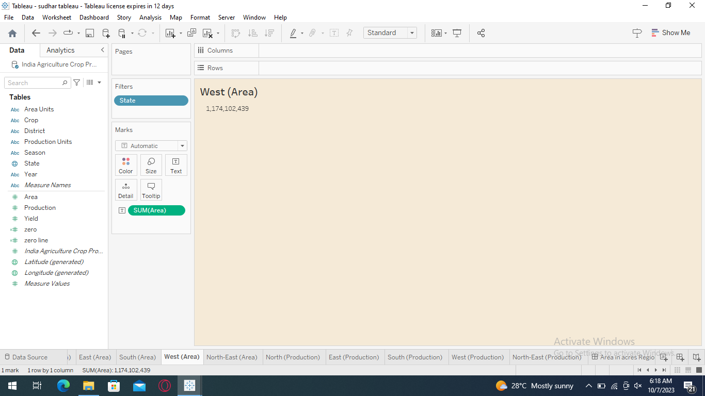

**NORT-EAST (Area)**

The following figure shows that North-Eastern land area of India. This region is known for its lush green landscapes, hills and diverse cultures.

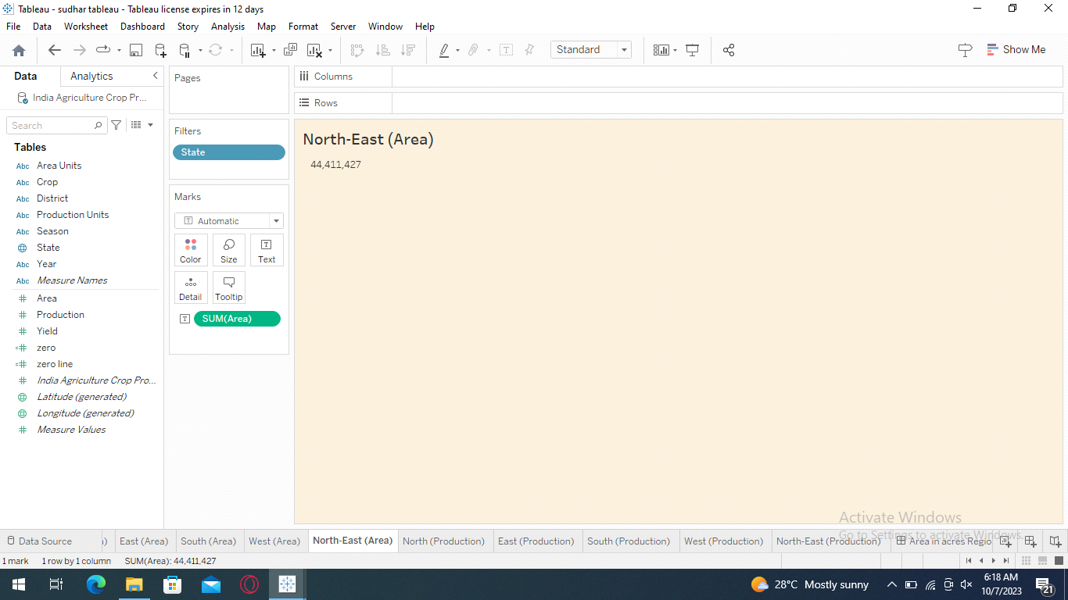

**NORTH AREA PRODUCTION**

The following figure shows that the production in Northern area. This data helps to know which plants are grown this area and calculating total production of yields in this region.

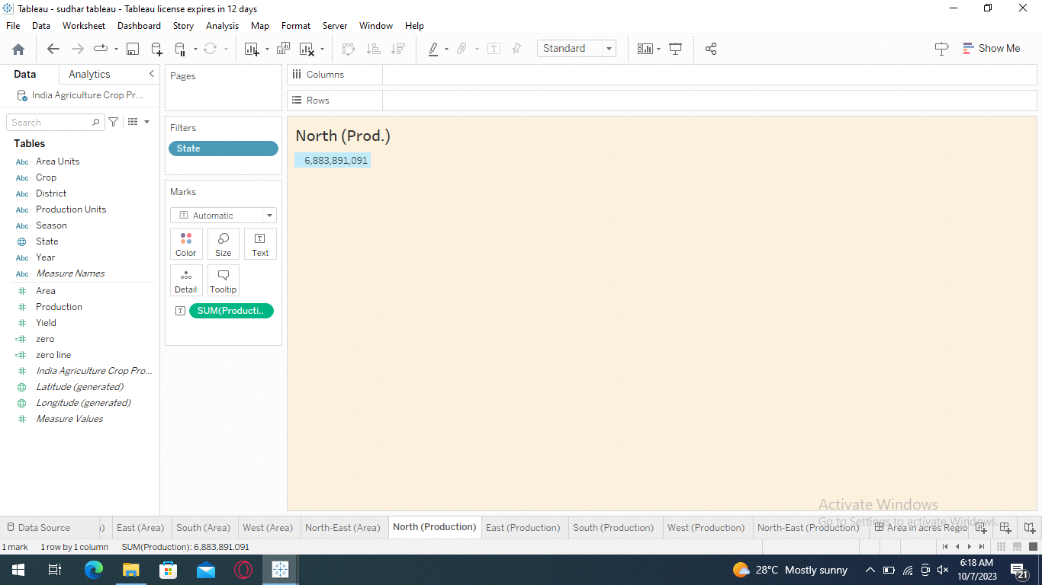

**EAST AREA PRODUCTION**

The following figure shows that the production in Eastern area. This data helps to know which plants are grown this area and calculating total production of yields in this region.

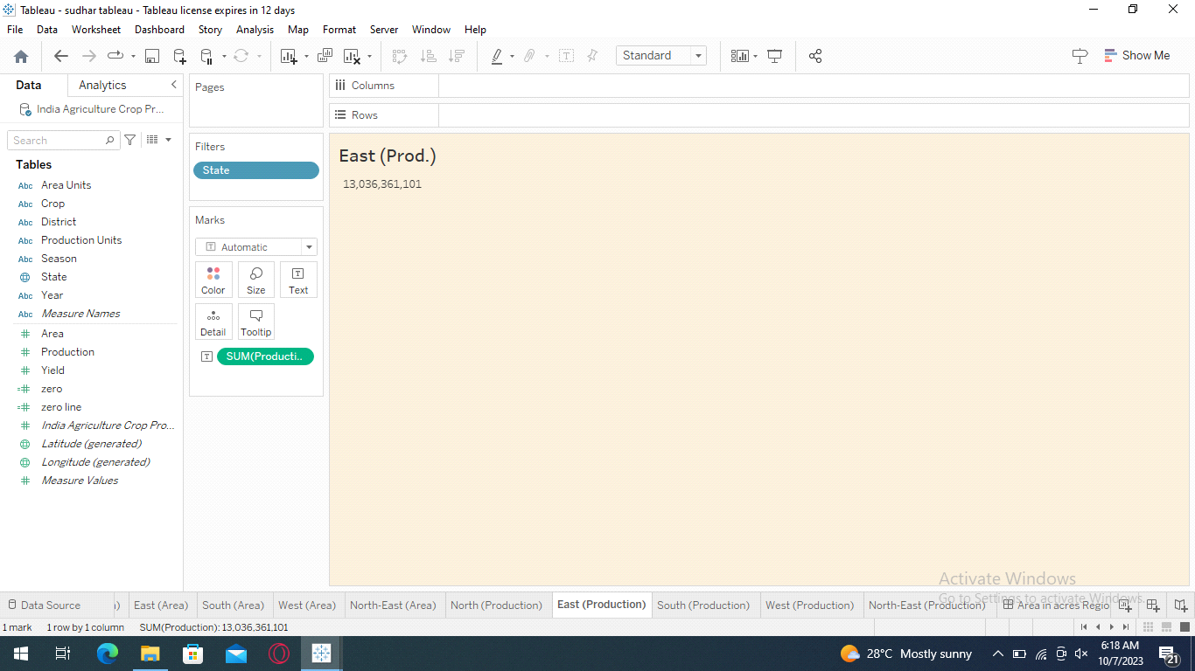

**SOUTH AREA PRODUCTION**

The following figure shows that the production in Southern area. This data helps to know which plants are grown this area and calculating total production of yields in this region.

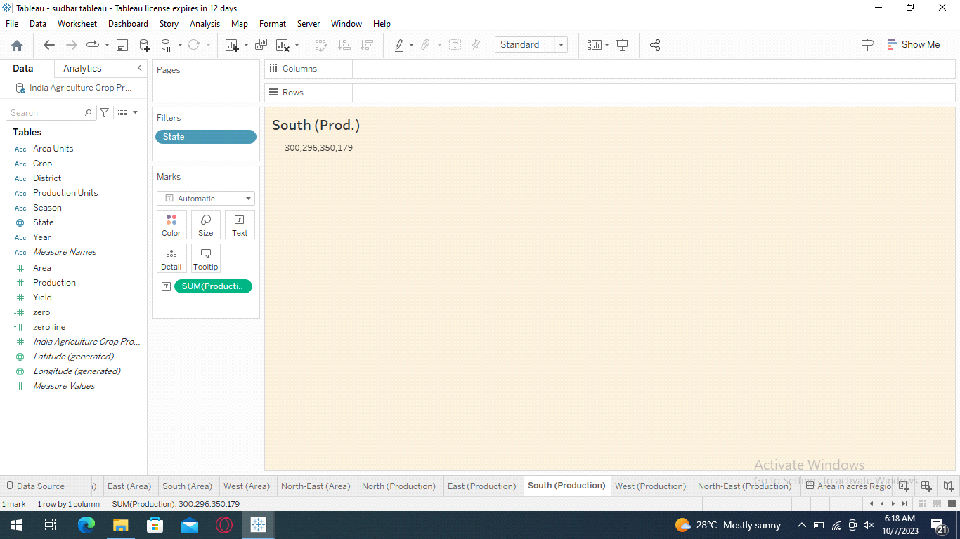

**WEST AREA PRODUCTION**

The following figure shows that the production in Western area. This data helps to know which plants are grown this area and calculating total production of yields in this region.

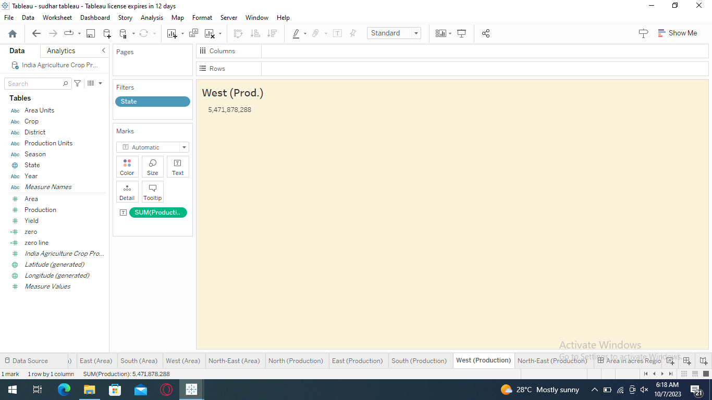

**NORTH-EASST AREA PRODUCTION**

The following figure shows that the production in North-East area. This data helps to know which plants are grown this area and calculating total production of yields in this region.

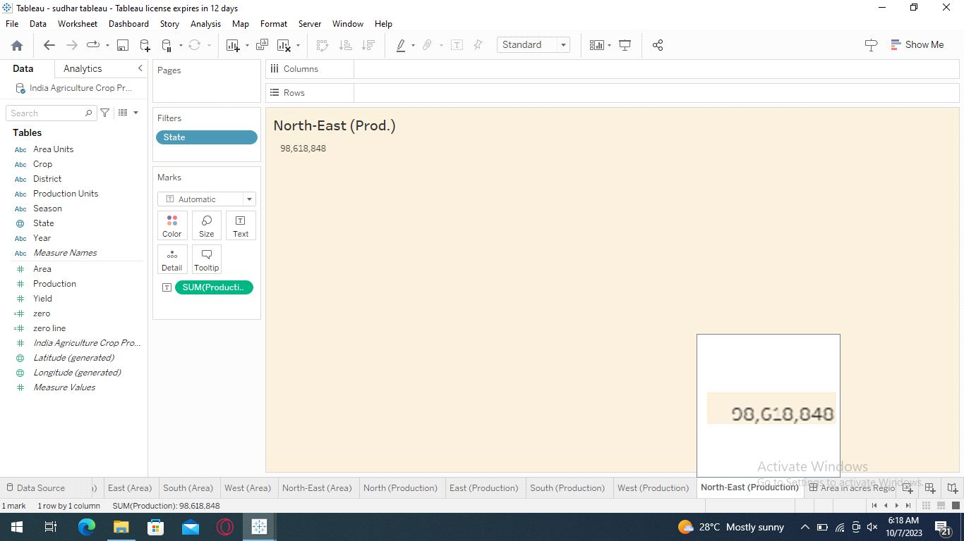

**DASHBOARD 1 (Area in acres region-wise)**

The following figures shows that area in acres region-wise. It comprises of statewise agricultural land and production in an area. This data will helpful to known the which state give higher yield or production.

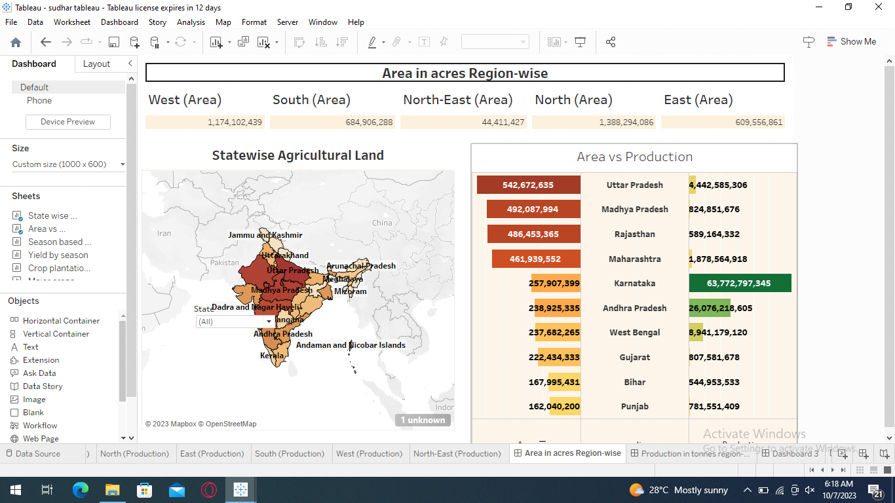

**DASHBOARD 2 (Production in tonnes region-wise)**

The following figure shows that region-wise production in tonnes. It includes seasoned based cultivation crop plantation by area and crop plantation by count. This data analysis crop cultivation by season and plantation in area.

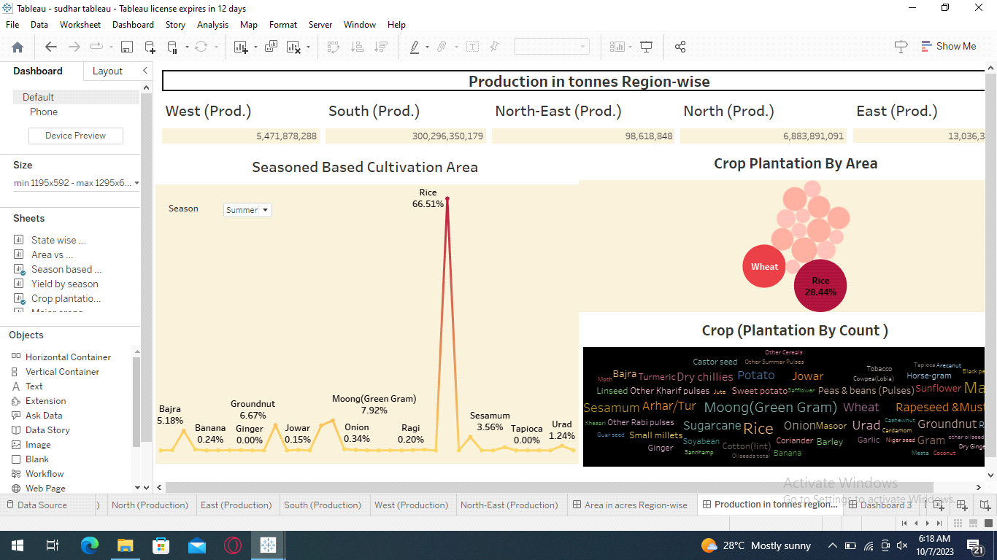

**DASHBOARD 3**

The following figure includes yield by season, seasonwise production and major crops. This data which helps to know the yield and production in changes of season.

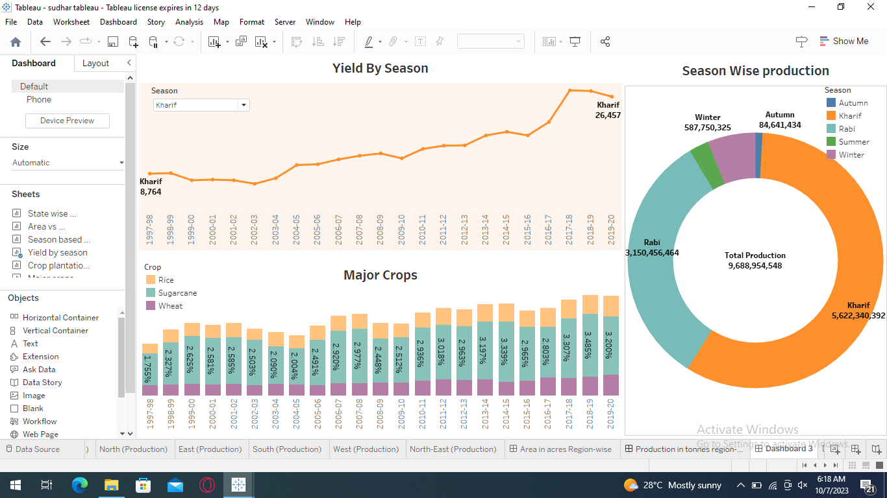

**STORY 1**

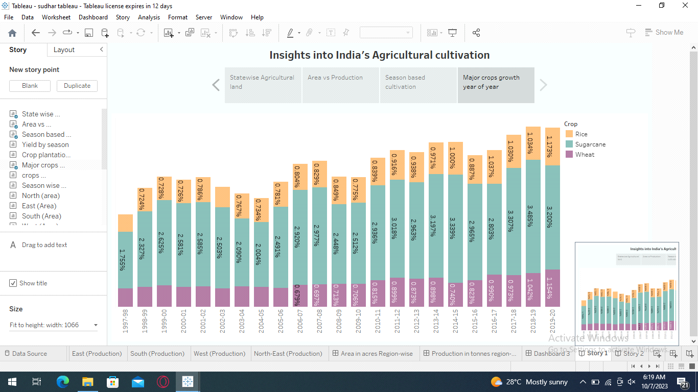

**STORY 2**

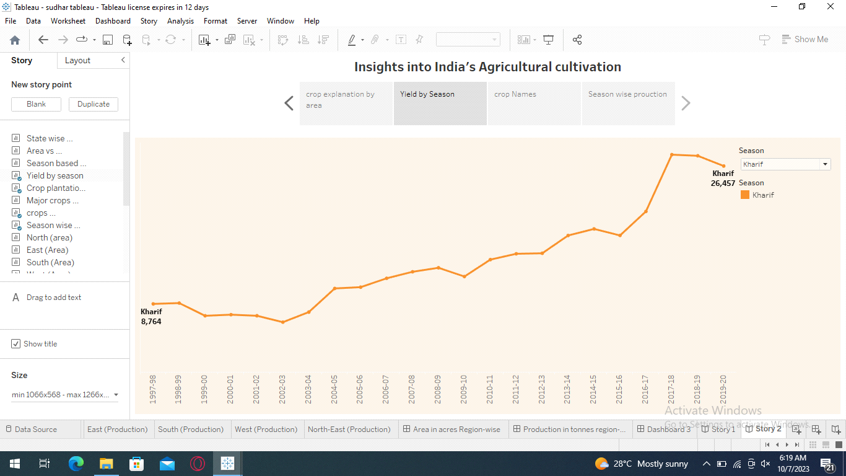

**4. ADVANTAGES & DISADVANTAGES**

**4.1 ADVANTAGES:**

The followings are advantages of analyzing the crop production by tableau:

* India witnessed significant growth in crop production during this period, making it one of the world’s leading agricultural producers. Key crops like rice, wheat, and pulses saw substantial increases.
* India’s diverse agro-climatic zones allow for the cultivation of a wide variety of crops, reducing dependency on a single crop and enhancing food security.
* India became a major exporter of agricultural products, including rice, wheat, and spices, boosting the country’s economy.
* Agriculture continued to be a significant source of employment, particularly in rural areas, supporting livelihoods.
* Agriculture continued to be a significant source of employment, particularly in rural areas, supporting livelihoods.

**4.2 DISADVANTAGES**

The disadvantages of analyzing the data of crop production by tableau are following;

* Disparities in crop yields persisted due to unequal access to resources, such as irrigation and technology, leading to income inequality.
* Overuse of chemical fertilizers and pesticide led to soil degradation and environmental issues, affecting long-term sustainability.
* Excessive groundwater extraction for irrigation resulted in declining water tables and increasing water stress in some regions.
* India’s agriculture remained vulnerable to climate change, with erratic rainfall patterns and extreme weather events impacting crop yields.
* Urbanization and industrialization led to the conversion of agriculture land into non-agriculture uses reducing arable land.

**5. APPLICATIONS**

Analyzing India’s agricultural production data by tableau from 1997 to 2021 can have various applications and uses across different sectors;

* Government agencies and policymakers can use the tableau analysis to formulate agricultural policies, such as subsidies, pricing mechanisms, and crop planning, to address issues and promote growth in the sector.
* Investors and financial institutions can use the tableau data to assess the performance and potential of the agricultural sector, guiding investment decisions in areas like agribusiness, technology, and infrastructure.
* Understanding production trends helps in assessing food security levels, which is crucial for ensuring a stable food supply for India’s growing population.
* Tableau analyzing the impact of climate change on crop yields during this period can inform strategies for climate adaptation in agriculture.
* Farmers and agricultural experts can use the tableau data to make informed decisions about crop diversification, shifting to more resilient and profitable crops based on historical performance.
* The tableau analysis can guide the allocation of resources such as irrigation, fertilizers, and research efforts to regions and crops that need them the most.
* Businesses in the agricultural sector, including traders and processors, can use the tableau data to forecast market trends, plan supply chains, and optimize pricing strategies.
* Urban planners can use the tableau data to understand the impact of urbanization on agriculture and plan for sustainable land use.

In summary, the tableau analysis of India’s agricultural production data from 1997 to 2021 has a wide range of applications, from policy formulation and investment planning to sustainability initiatives and rural development programs. It provides valuable insights for stakeholders across sectors to make informed decisions and promote the growth and resilience of India’s agricultural sector.

**6. CONCLUSION**

* highlighting the importance of balanced resource allocation, market stability, and environmental sustainability in ensuring a prosperous and resilient future The tableau analysis of India’s agricultural production from 1997 to 2021 presents a nuanced picture of progress and persistent challenges. During this period, India achieved notable increases in crop production, diversified its agriculture, and embraced modern technologies. This contributed to improved food security, economic growth through exports, and sustained rural employment.
* However, this growth was accompanied by disparities in yield and income, soil degradation from chemical overuse, water stress due to excessive groundwater extraction, vulnerability to climate change, and the hindrance of small landholdings. These issues underscore the need for addressing inequality, sustainable practices, and climate resilience.
* The application of this tableau analysis are far-reaching, with implications for policy formulation, investment planning, food security, climate adaptation, and rural development. It informs decision-makers, investors, farmers, and researchers, for India’s agriculture.
* Environmental sustainability and conversation became pressing concerns as agricultural practices sometimes led to soil depletion and environmental degradation. The COVID-19 pandemic disrupted supply chains and highlighted vulnerabilities in the agricultural sector, emphasizing the need for resilience.
* In conclusion, India’s agricultural production between 1997 to 2021 showcased both growth and challenges. Government support, technological advancements, and crop diversity played vital roles, but sustainability and climate change remain pressing issues. Balancing growth with environmental concerns will be crucial for the future of Indian agriculture.

**7. FUTURE SCOPE**

Analyzing the future scope and enhancement of India’s agricultural production between 1997 and 2021 requires a comprehensive study, but we can provide some general insights:

* The use of technology, such as precision farming, genetic engineering, and advanced machinery, is likely to continue to enhance agricultural productivity in India. These technologies can help increase crop yields and reduce losses due to pests and diseases.
* There is a growing trend towards diversifying crops beyond traditional staples like rice and wheat. This diversification can help reduce risks associated with monoculture and provide opportunities for higher-value crops.
* Improved irrigation methods, such as drip irrigation and rainwater harvesting, can play a crucial role in ensuring consistent crop yields, especially in regions prone to water scarcity.
* Government policies and subsidies will continue to influence agricultural practices. Policies that promote sustainable farming practices and provide support to small and marginal farmers can lead to overall growth in the sector.
* The use of digital technologies, such as mobile apps and data analytics, can empower farmers with information on weather forecasts, market prices, and best farming practices
* Climate change poses challenges to agriculture, but also opportunities for adaptation. Developing climate-resilient crop varieties and practices will be essential to secure future production.
* Growing awareness of health and environmental concerns may lead to increased interest in organic farming, both for domestic consumption and export,

It’s important to note that challenges like land degradation, water scarcity, and income disparities among farmers also need to be addressed for sustainable agricultural growth. Continuous research, policy support, and innovation will be key factors in enhancing India’s agricultural production in the coming years.